Link Referensi Tugas Akhir LAB Furniland:
- Garry Clementius Suhandinata – 2802392633
- Jhon De Floretto - 2802481986
- Richard Susanto – 2802511250
- Ridhan Achmad Rozzaqu Sayuti – 2802535175
Link Referensi Gambar Product:
- https://myseat.sg/collections/standing-desks/

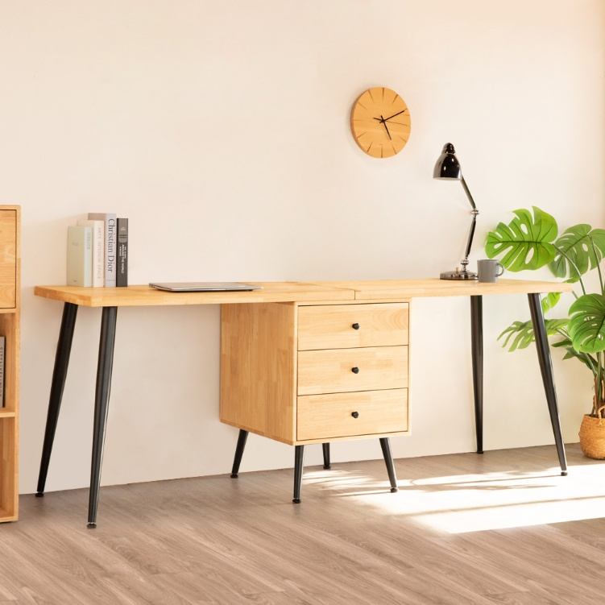

- https://m.media-amazon.com/images/I/71wsjBT9E-L._AC_SY300_SX300_QL70_FMwebp_.jpg

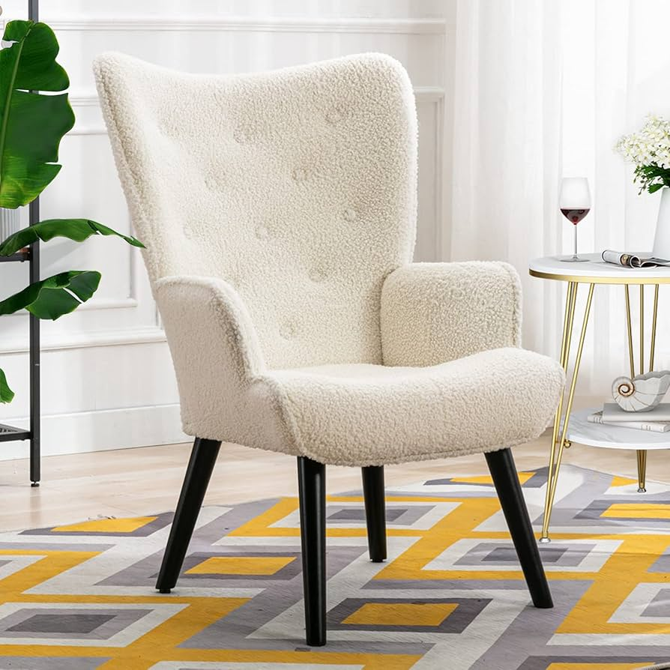

- https://pixelinteriorfitout.com/cdn/shop/files/IMG_1297.jpg?v=1758007280&width=1200
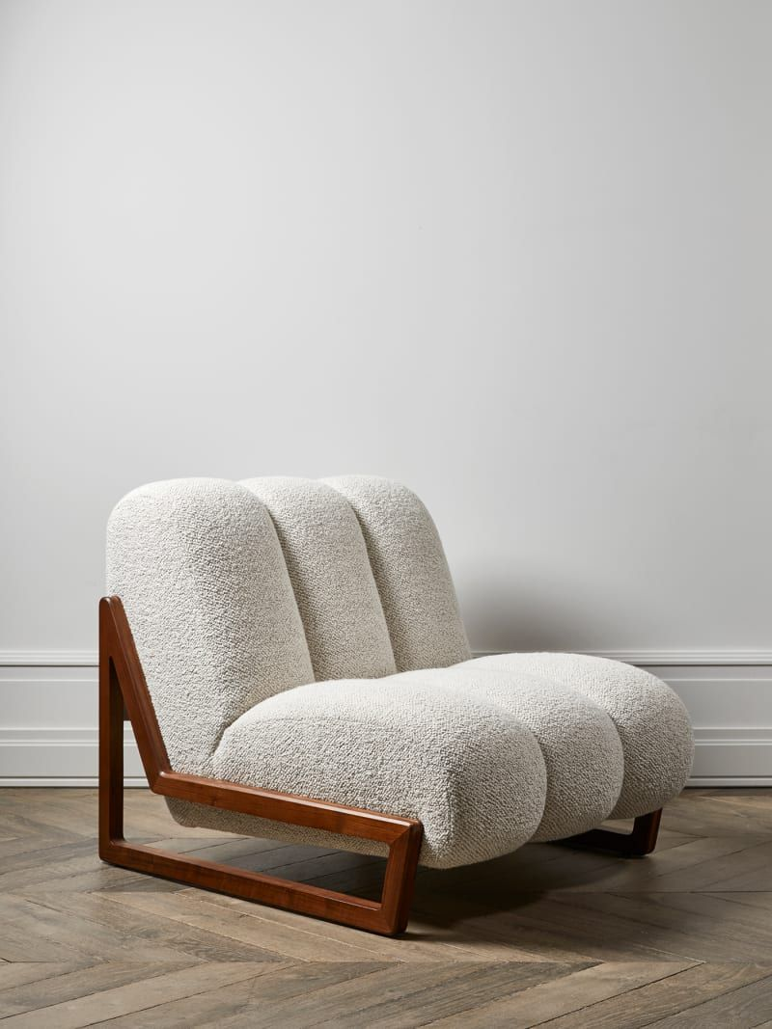

- https://www.tokopedia.com/kimmysofa/kimmy-sofa-sofabed-pillowtop-full-dacron-tebal-empuk-dan-berkualitas-darkbrown-meja-kinko-637ba
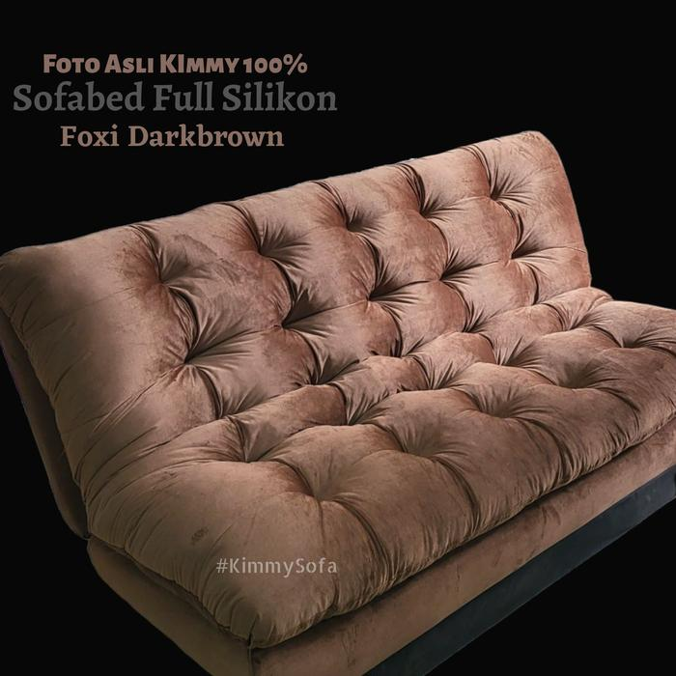

- https://encrypted-tbn0.gstatic.com/images?q=tbn:ANd9GcR1mH3yXVu2MzacnWwxTZIdBJduFjpc1q9_9CfiIssSj4uE6_7L
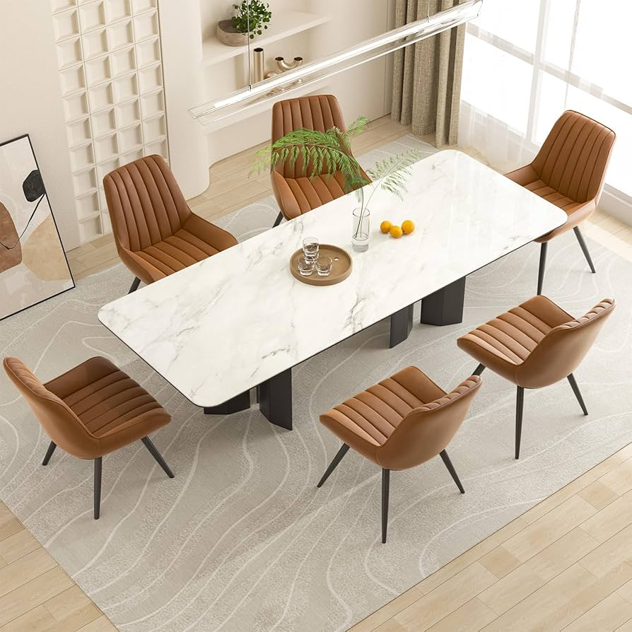

- https://encrypted-tbn3.gstatic.com/images?q=tbn:ANd9GcQwMTGflnAxAhKs9F4VulQS8Fvf0j6z3aEIuRxxP0mxRDLbZp8l
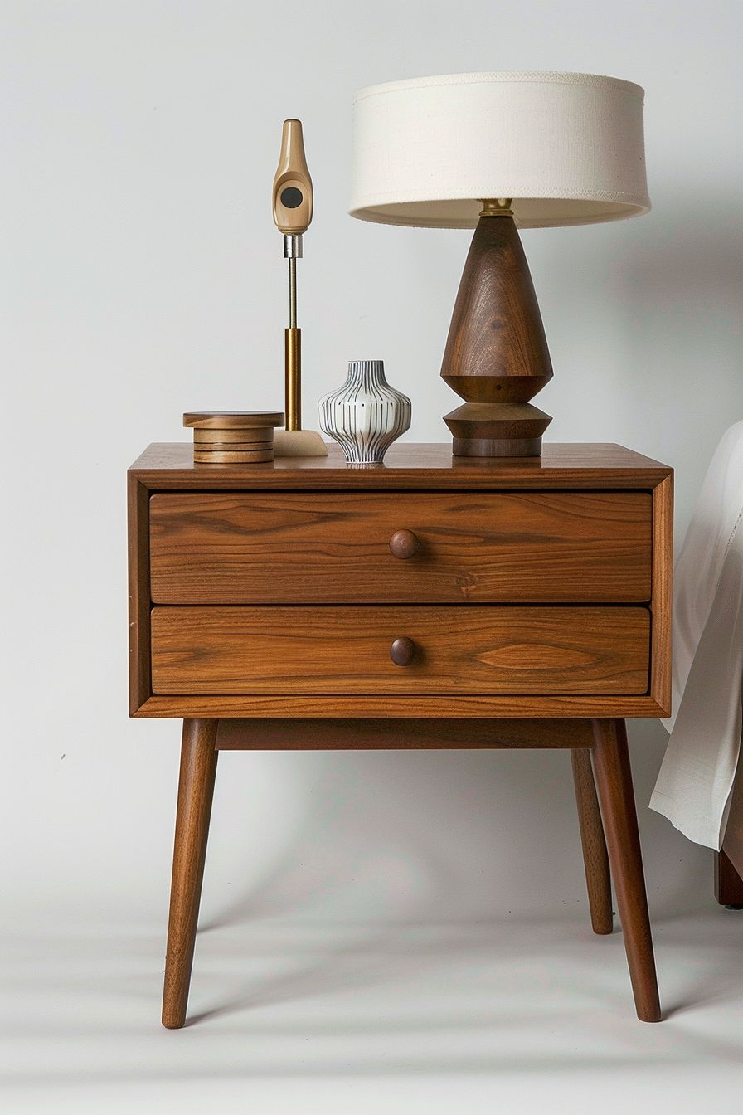

- https://encrypted-tbn0.gstatic.com/images?q=tbn:ANd9GcQGyhdPXtH6y2GyjZphh2P-rIfvW09QVTUwF6V5MsXBYjUFjSsm
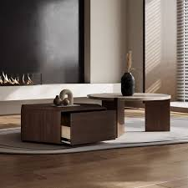

- https://encrypted-tbn2.gstatic.com/images?q=tbn:ANd9GcSzKX0eyo6zwDfSRbQU-HOS1fjOH6cLxR9vOU6V_TKzMLH-oNLr
